Chandra Prakash Babu Ponduri, H664K297
CS-891-24556-Spring 2026
AsiaBazzar
https://theasiabazzar.com/

Table of Contents
Introduction : 1
Project Overview: 1
Problem Statement: 2
Main Modules: 3
Customer Module 3
Admin Module 3
Integration Module (System Backbone) 4
Features: 4
User Authentication 4
Signup 4
Log In: 5
Forget Password: 6
Product Browsing 7
Home page: 7
Grocery Store: 7
Café: 10
Cart Management: 10
Checkout and Payments 10
Orders: 13
Customer Profile: 13
Admin Management: 15
Media and Notifications 20
Core User Flows 20
Customer Shopping Flow 20
Forgot Password / Reset Password Flow 20
User Profile Update Flow 21
Admin Order Management Flow 21
Admin Product Management Flow 21
Payment Checkout Flow (Card) 21
Pages and Route Map: 22
Public Routes: 22
Protected Customer Routes 22
Admin Routes (Protected, Admin Only) 22
Route Protection Summary 23
Technology Stack 23
Frontend 23
Backend 23
Database 24
Storage & Deployment 24
Development Tools 24
Conclusion 24

Introduction :
Asia Bazaar is a full-stack web application for online grocery and cafe ordering. It helps customers browse products, place pickup or delivery orders, and track order history. It also provides an admin panel for managing products, users, orders, and payments.

# Goals
- Provide a single digital storefront for grocery and cafe products.
- Enable smooth checkout with multiple payment methods.
- Give admins complete operational control through a dashboard.

Project Overview:
Project Name: Asia Bazaar Grocery and Cafe Ecommerce Application
Project Type: Full-stack web application
Architecture: React (frontend) + Node.js/Express (backend) + MongoDB (database)
Asia Bazaar is an ecommerce platform built for a real grocery and cafe business use case. The application combines customer shopping features and admin management tools in one system. Customers can browse store and cafe products, add items to cart, place pickup or delivery orders, and track their order history. Admin users can manage products, monitor users, process orders, and update payment/order statuses from a centralized dashboard.
Purpose
- Digitize grocery and cafe ordering into one online platform.
- Improve customer convenience with search, cart, and checkout flows.
- Streamline business operations using admin dashboards and management tools.
Target Users
- Customers who want to order grocery and cafe items online.
- Admin/staff users who manage catalogue, orders, payments, and users.
Business Value
- Reduces dependency on manual/phone-based ordering.
- Improves order visibility and tracking for both customers and staff.
- Enables scalable day-to-day operations through structured workflows.

Problem Statement:
Traditional grocery and cafe ordering is often handled through in-person visits, phone calls, or unstructured messaging. This creates major operational and customer experience issues.
Existing Problems
- Customers have limited convenience because ordering depends on store timings and manual communication.
- Product discovery is difficult due to no centralized, searchable digital catalogue.
- Order tracking is weak, so customers and staff cannot easily see current order/payment status.
- Checkout is inconsistent, with limited structured support for delivery type and payment options.
- Admin operations are inefficient because product updates, user oversight, and order handling are not centralized.
Need for the Solution
A unified digital platform is needed to:
- Offer a structured online storefront for grocery and cafe items.
- Support end-to-end order flow from browsing to checkout and status tracking.
- Provide admin tools for managing products, orders, payments, and users in one place.
How This Project Solves It
The Asia Bazaar application solves these issues by delivering:
- A customer-facing ecommerce experience (/store, /cafe, cart, checkout, profile).
- Multi-option checkout (pickup/delivery + online/cash payment handling).
- Order visibility for customers and admins.
- A protected admin dashboard for daily business operations and control.

Main Modules:

Customer Module
The Customer Module handles all user-facing shopping and account flows.
Includes:
- User signup, login, and logout
- Forgot password and reset password flow
- Home page with Store and Cafe navigation
- Grocery and Cafe product browsing
- Search and filter options for products
- Product detail view with related items
- Cart management (add, update quantity, remove)
- Multi-step checkout flow
- Delivery/pickup and payment method selection
- User profile update
- Customer order history and status tracking

Admin Module
The Admin Module supports business operations and control through protected routes.
Includes:
- Admin-only access control (/admin)
- Dashboard with key business metrics
- Product management (add, update, soft delete)
- Order management (view, filter, update status)
- Payment status monitoring and updates
- User listing and search
- Reviews section (currently mock-data based)

Integration Module (System Backbone)
This module connects frontend, backend, and external services.
Includes:
- REST API communication between client and server
- JWT-based authentication and authorization
- MongoDB data persistence
- Stripe payment intent and card payment integration
- Email support for password reset and order notifications
- Image upload/storage support for product assets

Features:

User Authentication
- User signup and login with JWT-based authentication.
- Secure password hashing and token-based session handling.
- Forgot password and reset password flow through email link.
- Protected routes for logged-in users and admin-only pages.
Signup: Users are required to fill in all mandatory fields to complete the signup process. Once registered successfully, they will be automatically redirected to the home page to proceed with placing an order.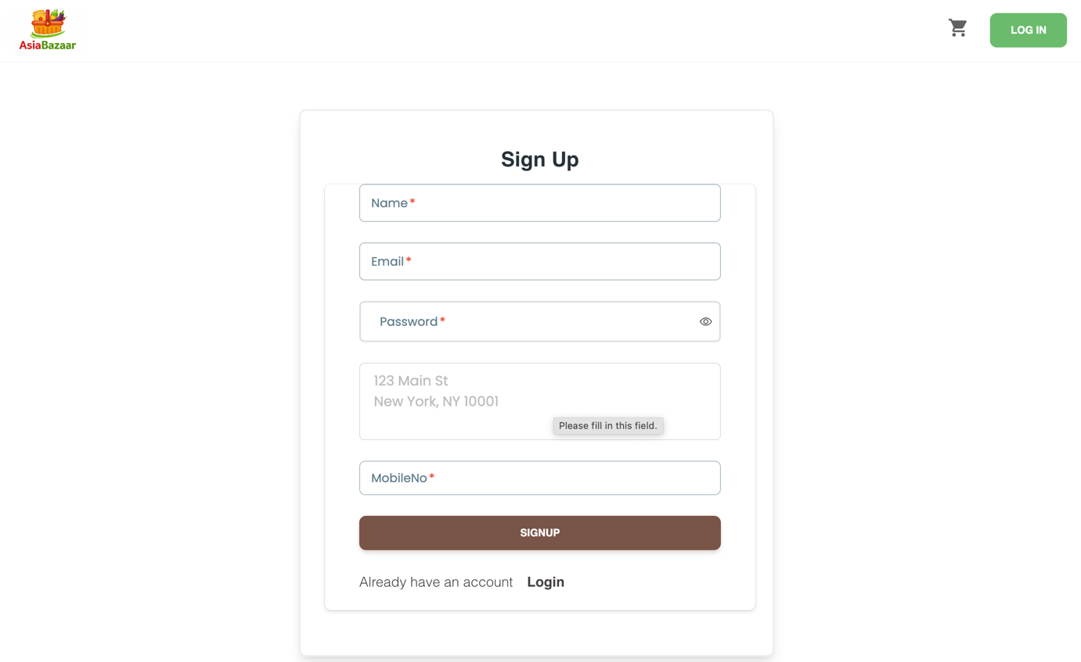

Log In:
If the user already registered, then user can just login with the existing credentials.
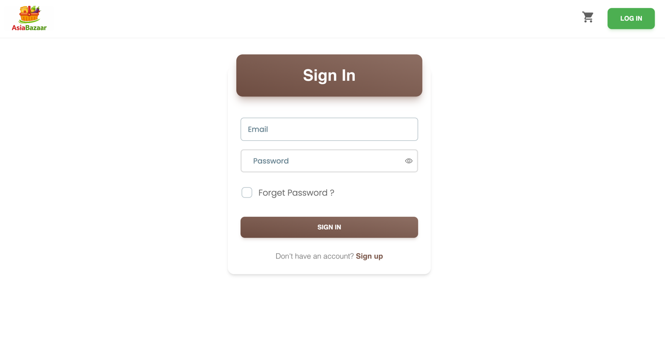

Forget Password:
After user enter the email and request to update his password, he will get the URL to update his password to the registered email.
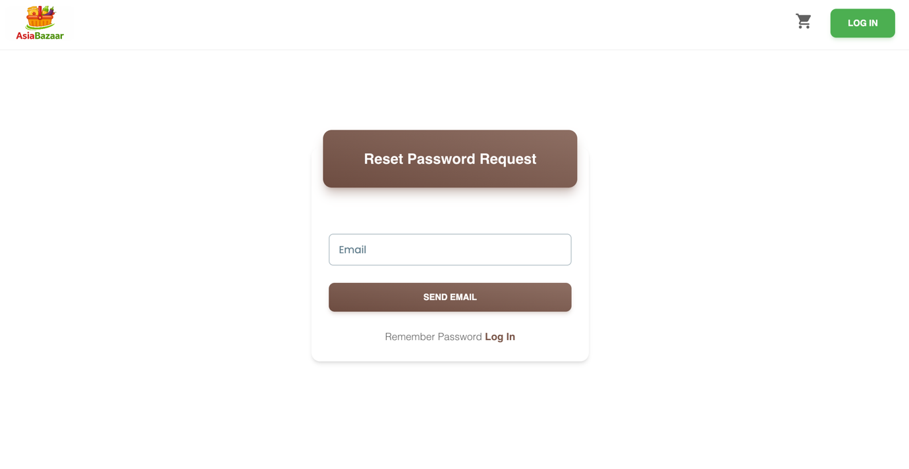
After we request for updating the password, We will get the mail to the registered email id, which includes the Website URL to update the password.
After open that URL, we can see a form to update our password. Just enter the password and retype it again then submit the form.
After updating the password you will redirect to login page. Just login with the new credentials.
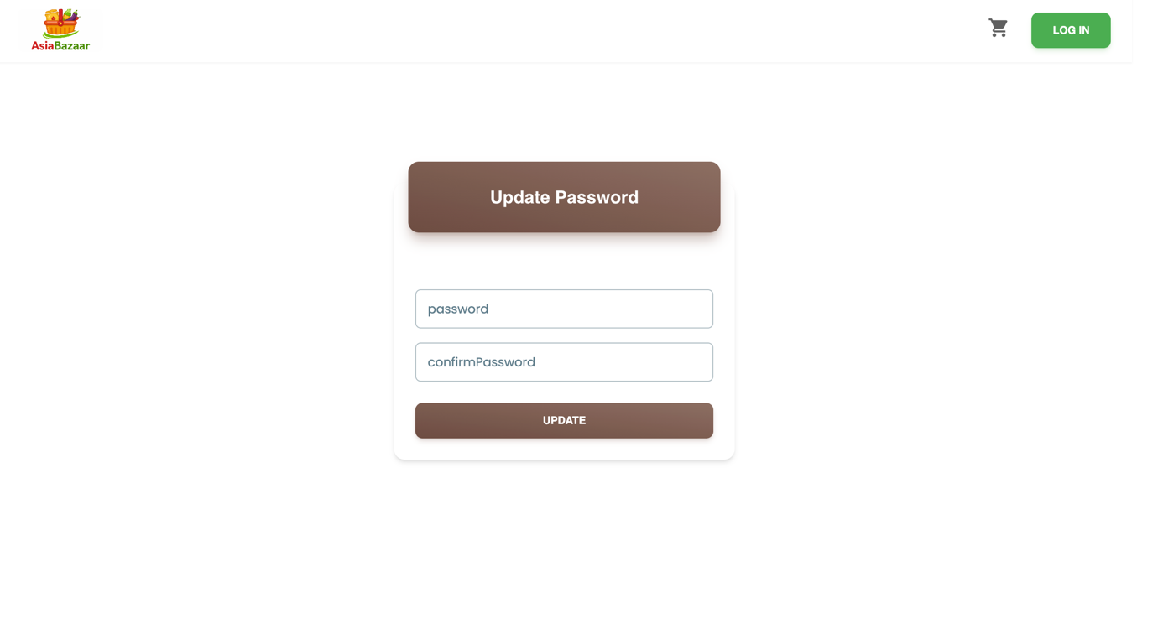

Product Browsing
- Separate browsing for Grocery Store and Cafe items.
- Search and filter options by category, stock, and discount.
- Product detail page with images and related products.
- Product cards with price, quantity/size, and stock visibility.

Home page:
Once login into the application, the users can see the two sections of the application.
- The grocery store
- Café Items

Grocery Store:
The grocery store section contains all the products which are available in the store like rice, milk, vegetables, frozen items etc..
Once we click the ‘Visit Store’ in home page we will relocate to the store section.
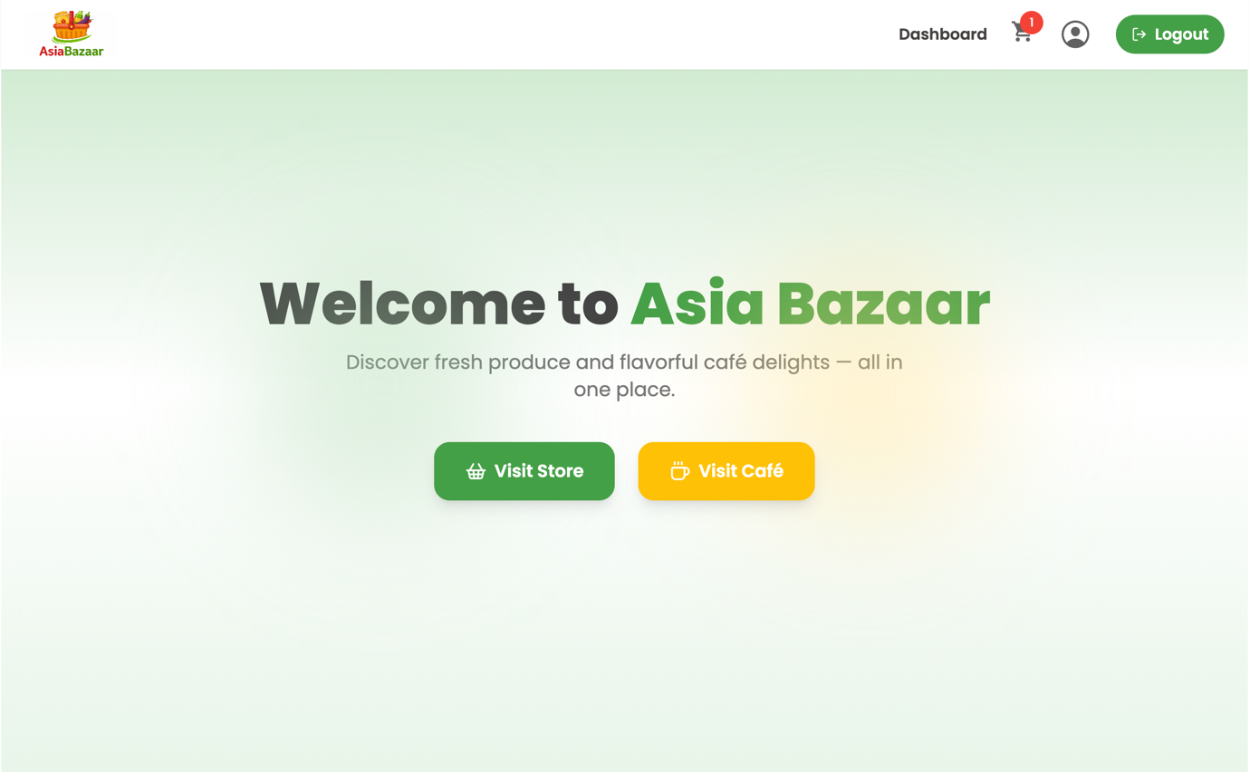
Browsing the Grocery Store Items:
- Search with the item name
- Seach based on Availability InStock / Out of Stock
- Search based on deals
- Seach based on category
- We can browse the items by just selecting the category icon under ‘Explore our categories’ Section.
In this picture we can see browsing the items with the filters. If we click ‘Reset All’ then we can see all available items.
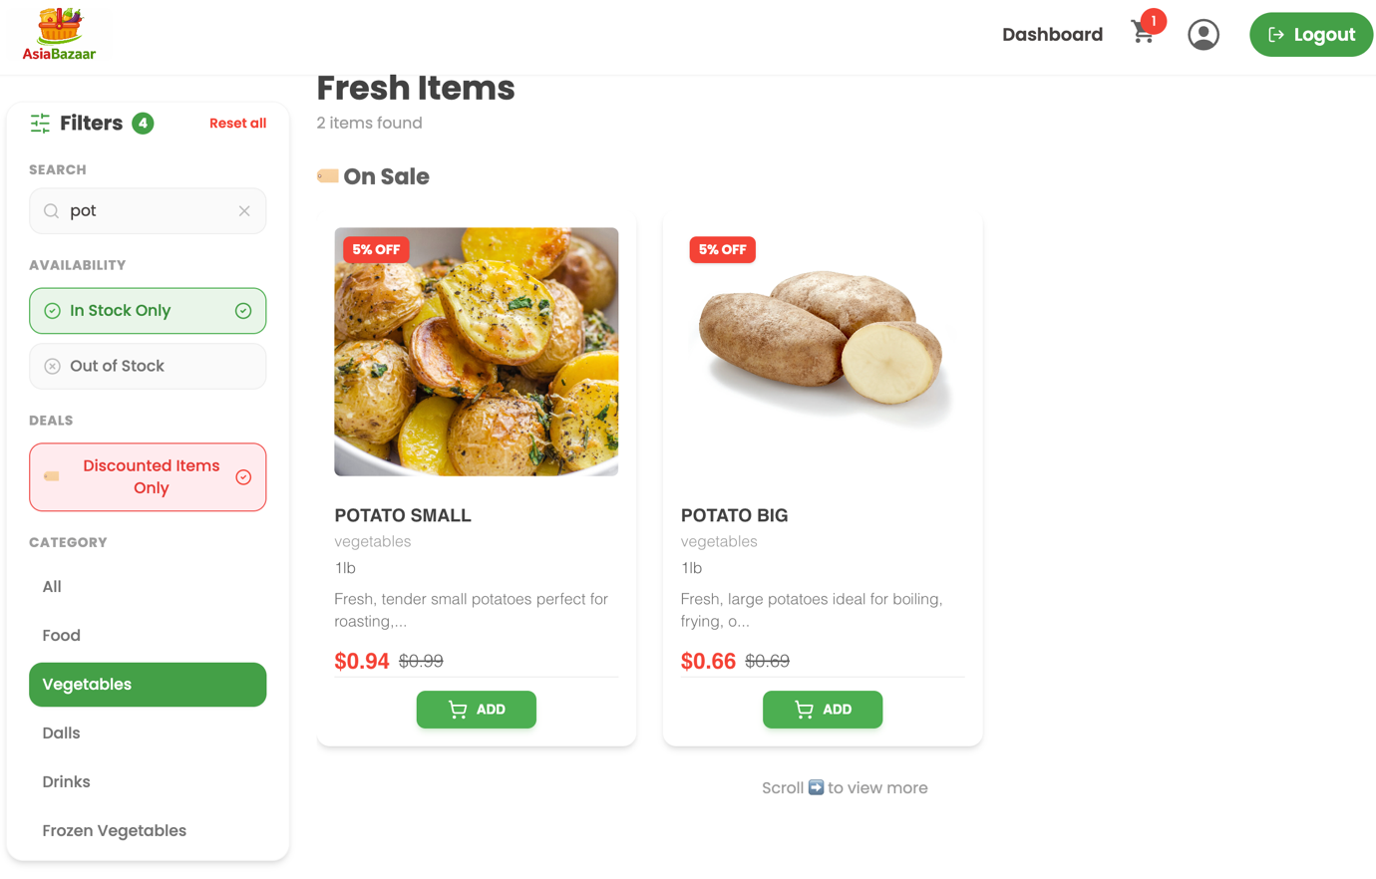

Product detailing page with the images and related products:
- Once we click on the product, we can see the product details and the related products under the product info.
- So we can check the details and if we want to add to cart, we can add any related product along with the main product.
- The price with the red color indicates that the item is on deal with some offer on price.

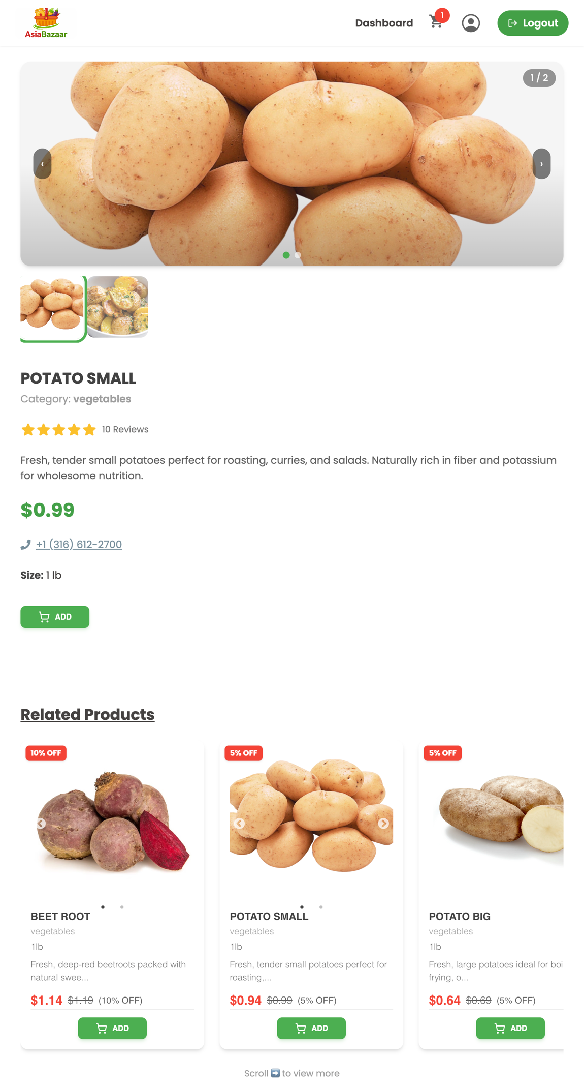

Café:
It is same like the store section, We can search products using filters and add to cart from the product screen or from cafe items.

Cart Management:
- Add items to cart with duplicate item handling.
- Update item quantities directly in the cart.
- Remove items from cart.
- Persistent cart data linked to user account.
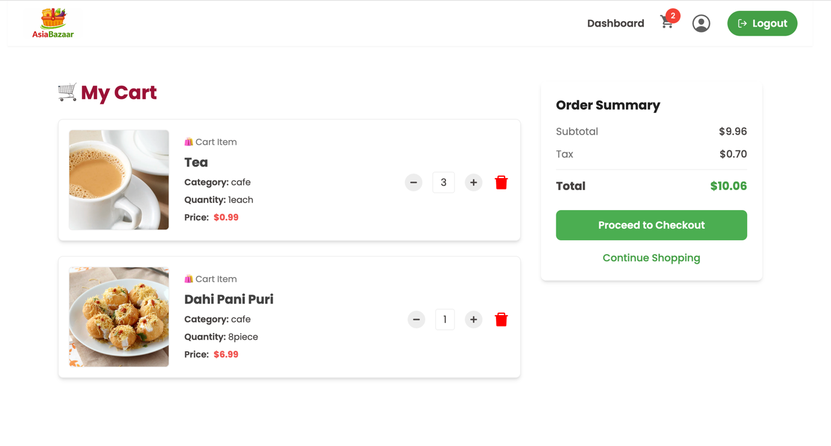

Checkout and Payments
- Multi-step checkout flow for better usability.
- Delivery options: pickup or home delivery.
- Payment options: pay on pickup, cash on delivery, or card.
- Stripe card payment integration using PaymentElement.
- Automatic total calculation with tax, shipping, and optional charges.

We can choose ‘Pickup’ or ‘Delivery’ method.
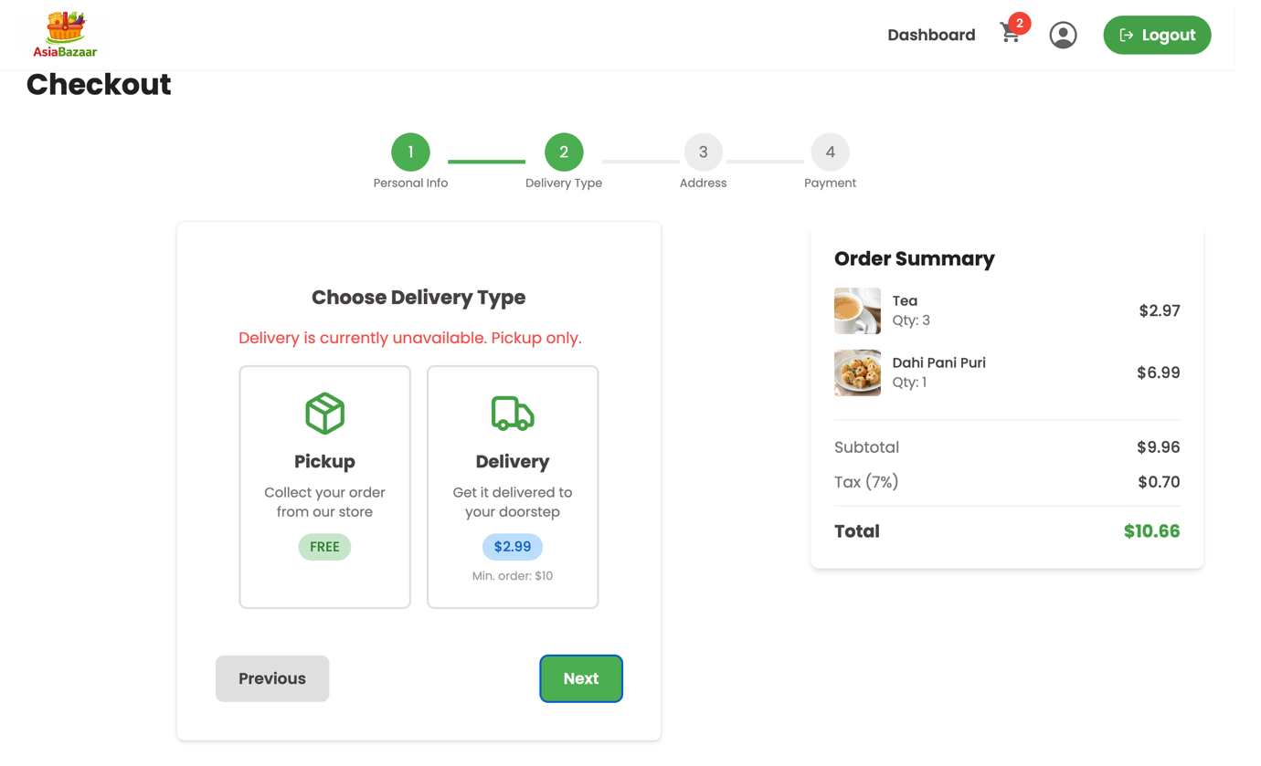

If it is ‘Pickup’ then the shipping fee is ‘Free’.
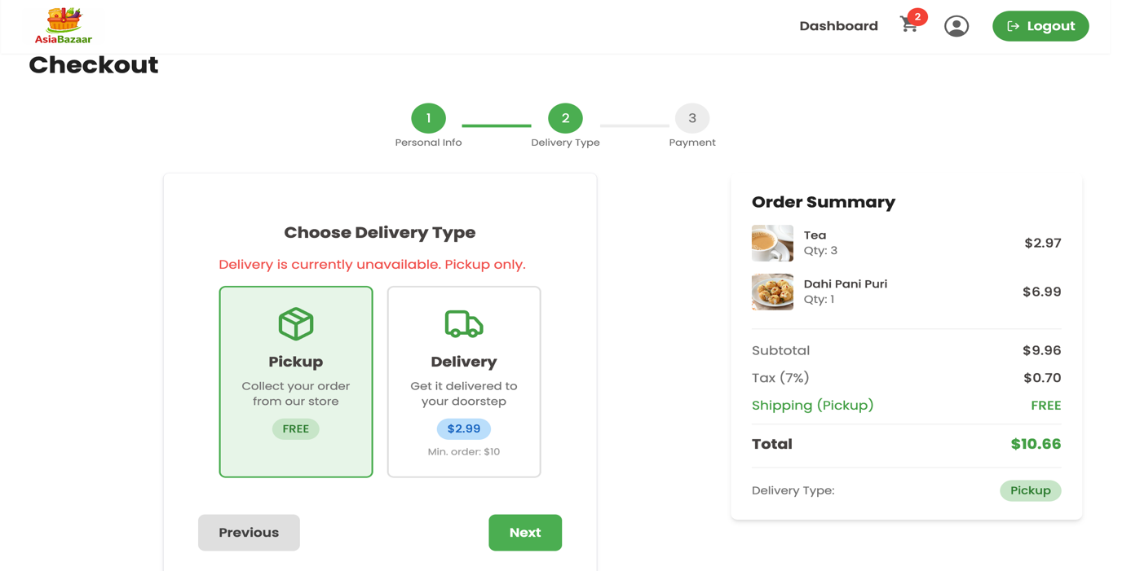

If it is ‘Delivery’ then we will have shipping fee.
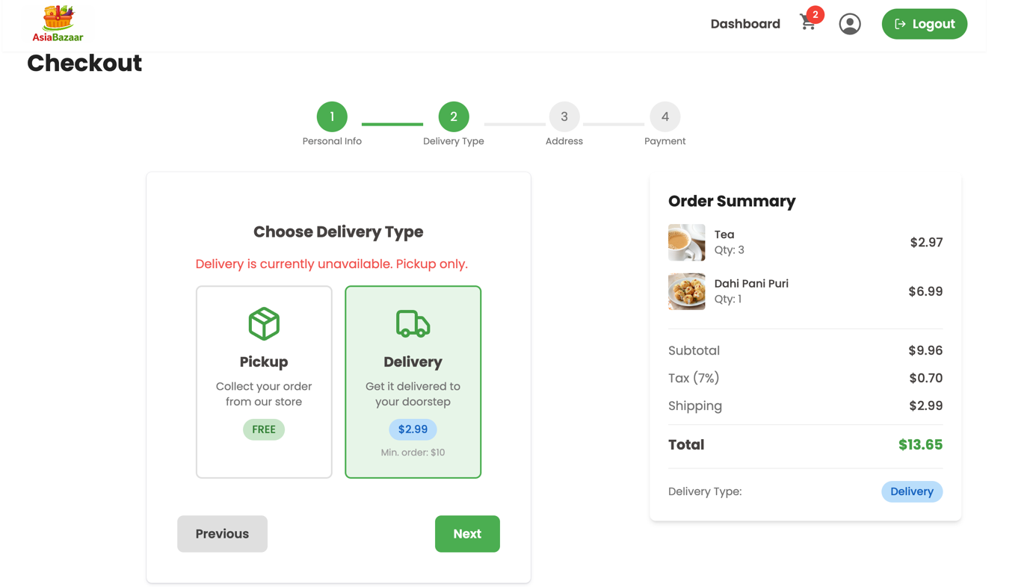

In next step we need to fill up the delivery address.
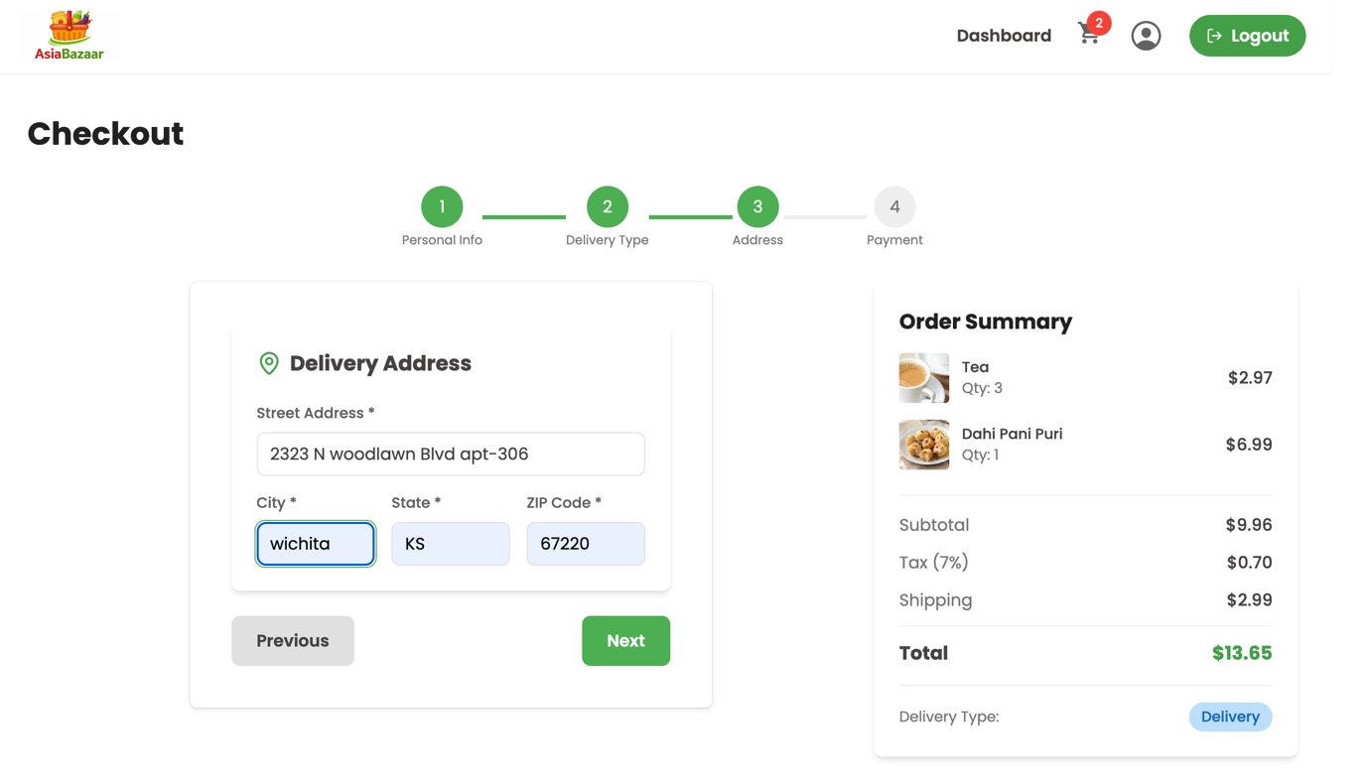

After that choose the ‘Payment Method’ . Here I choose the ‘Card Payment’. Once the Payment is done the order will be placed and the user will get the order details to registered mail ID.
User can see his orders in his profile.
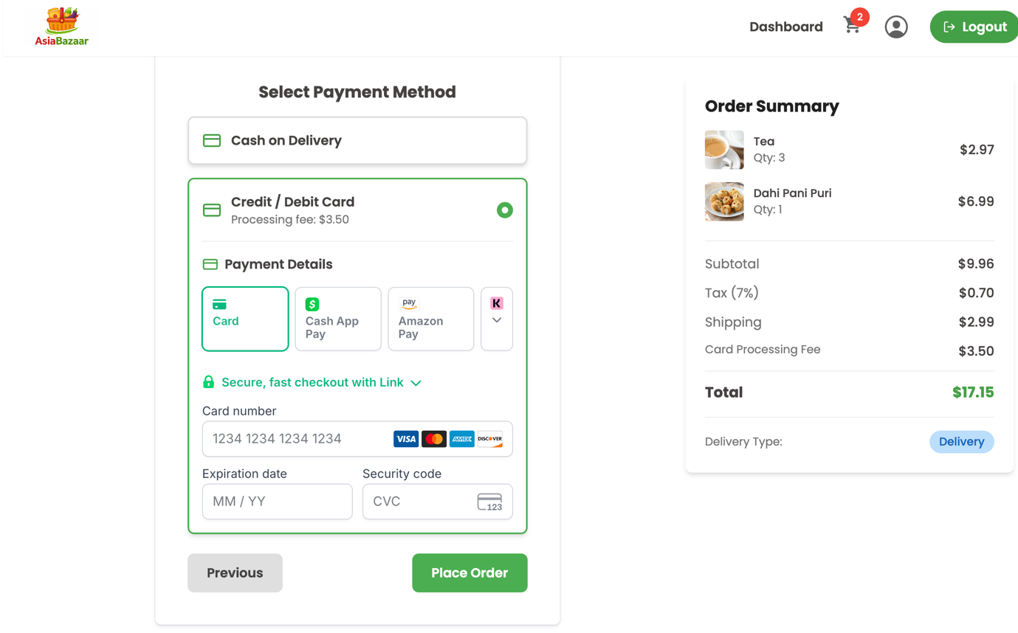

Orders:
- Create orders from cart with full item snapshot.
- Customer order history in profile.
- Order status and payment status tracking.
- Confirmation email after successful order placement.

Customer Profile:
The customers can see their orders in their profile, they can see the payment status and order delivery status too.
Customers can edit their profile details in the profile section.
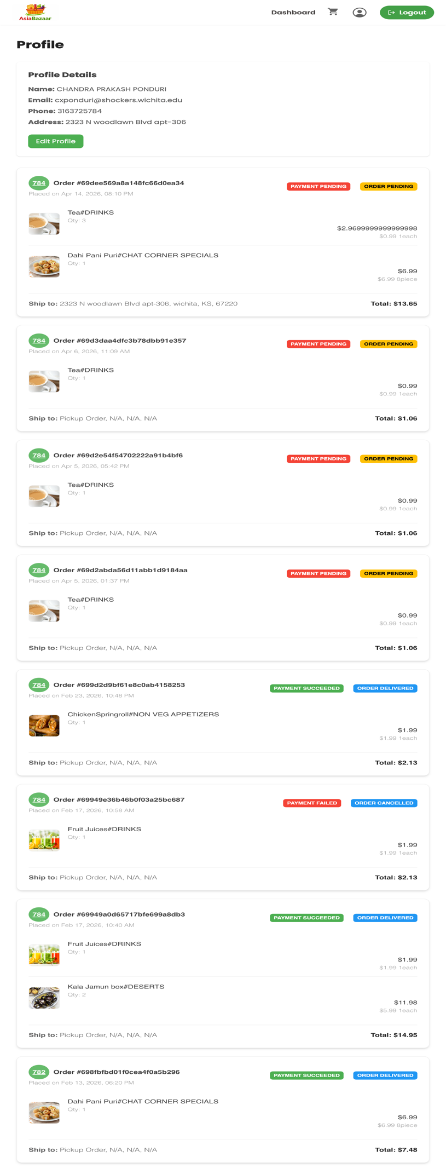

Admin Management:
- Admin dashboard with business summary metrics.
This is the admin dashboard, where the admin can access this. This is the home page of dashboard. It shows the total revenue on orders, total orders, customers and total products.
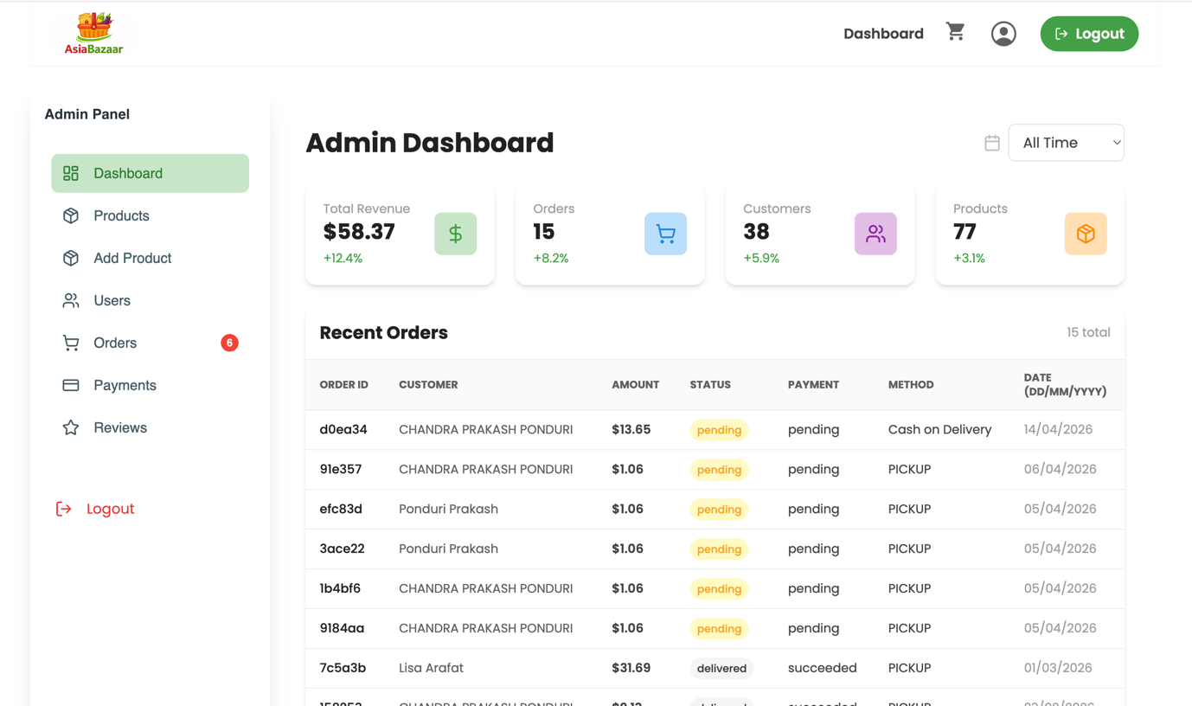

- Product management: add, update, and soft delete.
This is the products section. The admin can add new products with multiple images, he can delete the product, edit the product and add any discounts to the products. It has pagination and search features too.
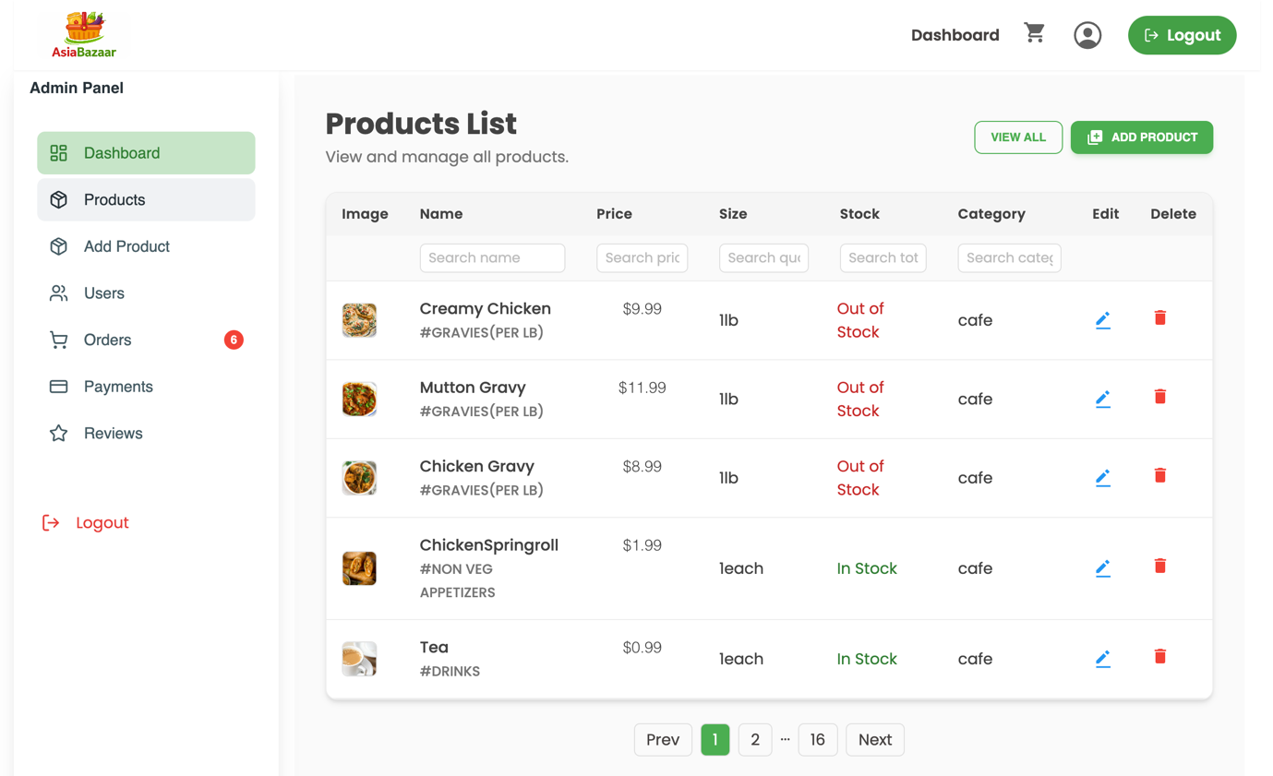
Edit the product:
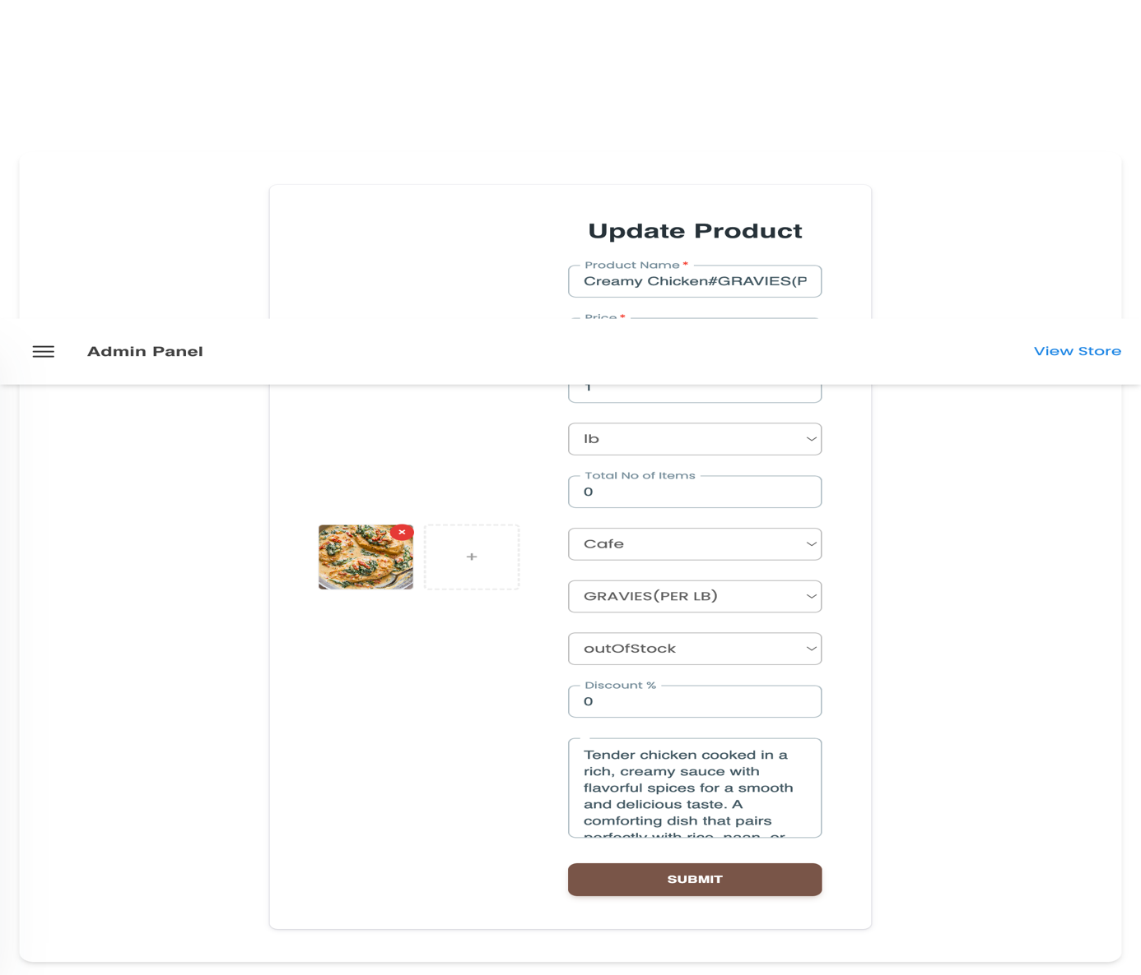
Add Product:
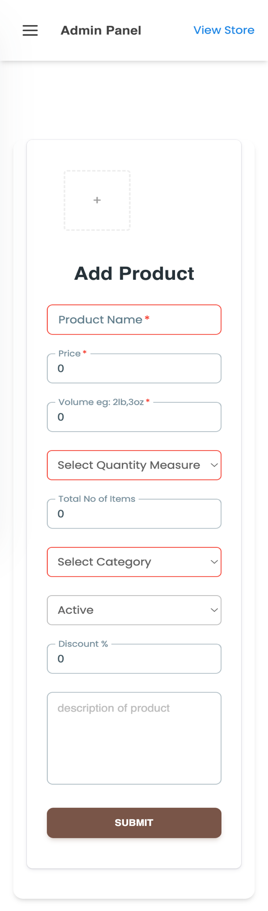

- Order management: view, filter, and update statuses.
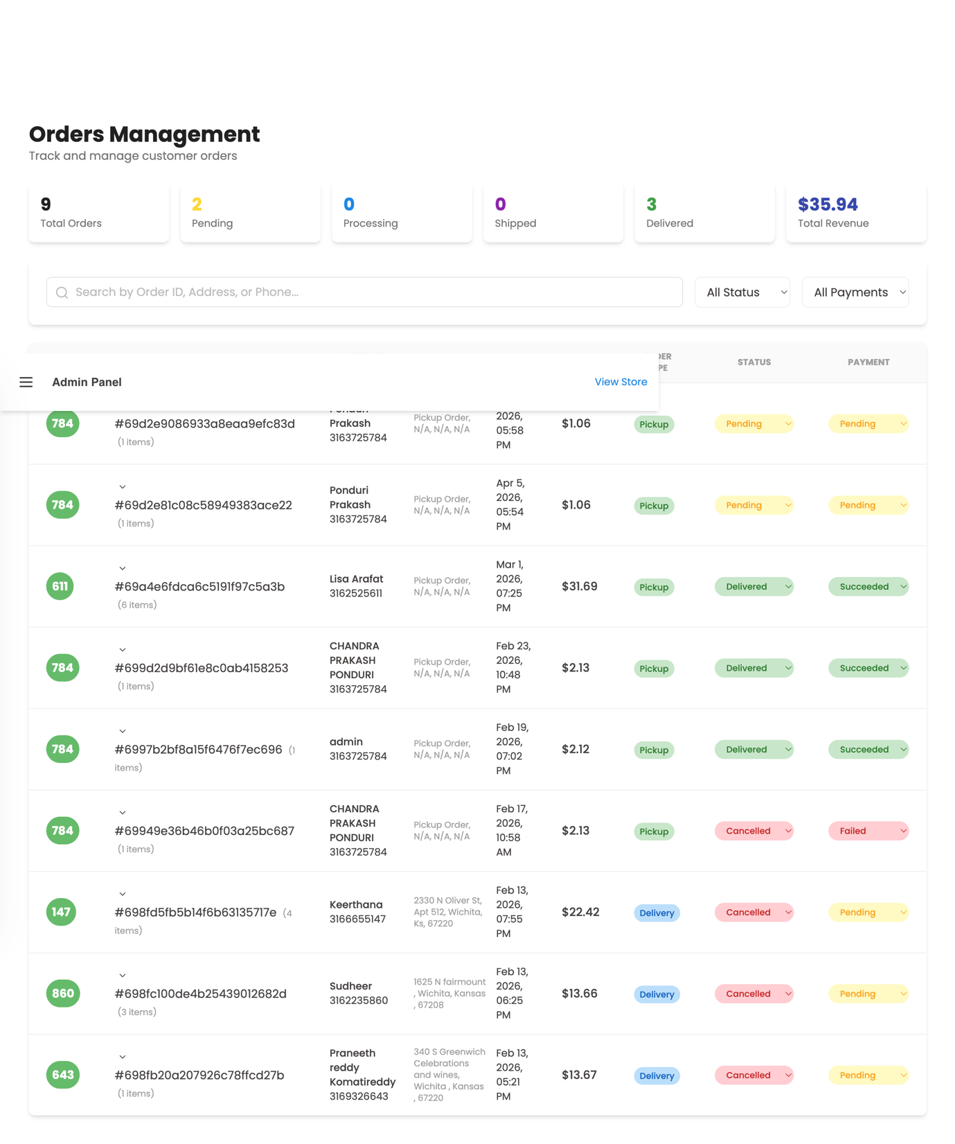

- User management with searchable user list.
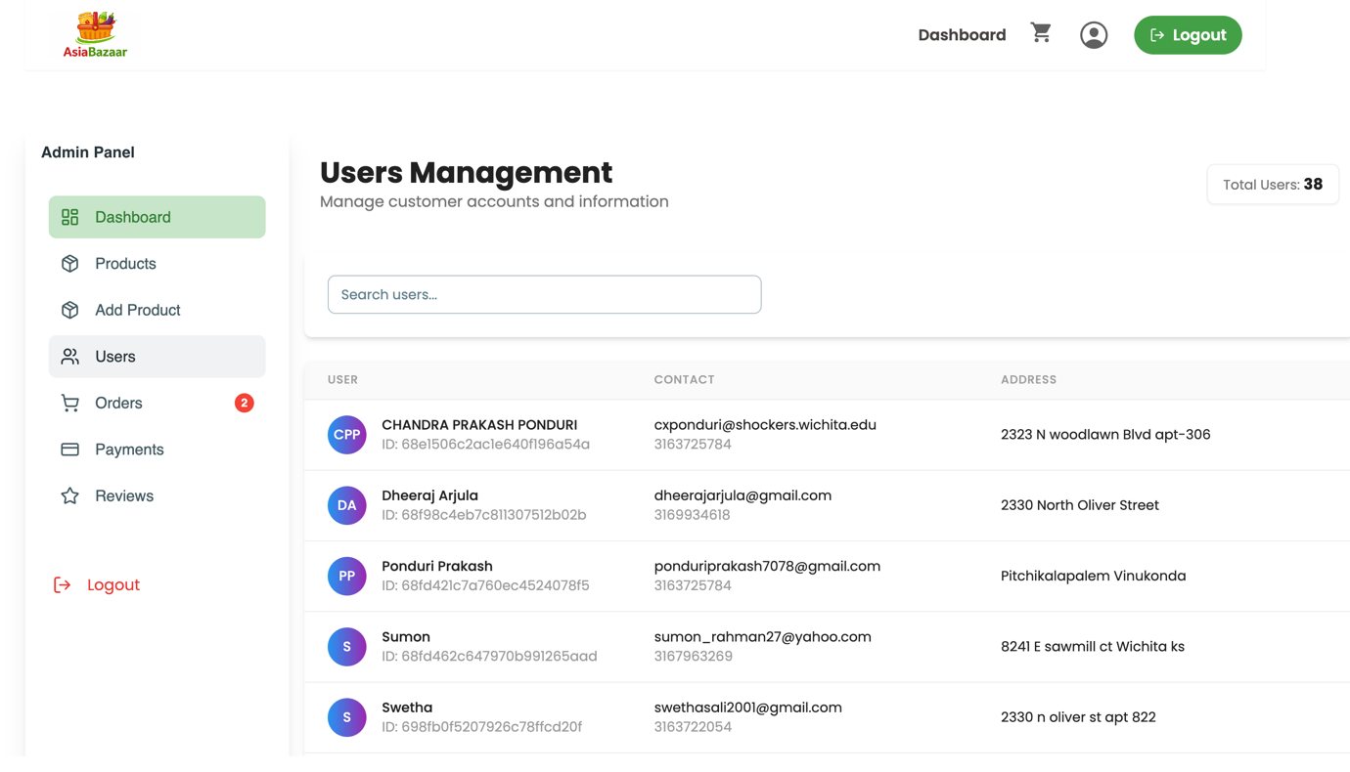

- Payment monitoring dashboard by payment state.
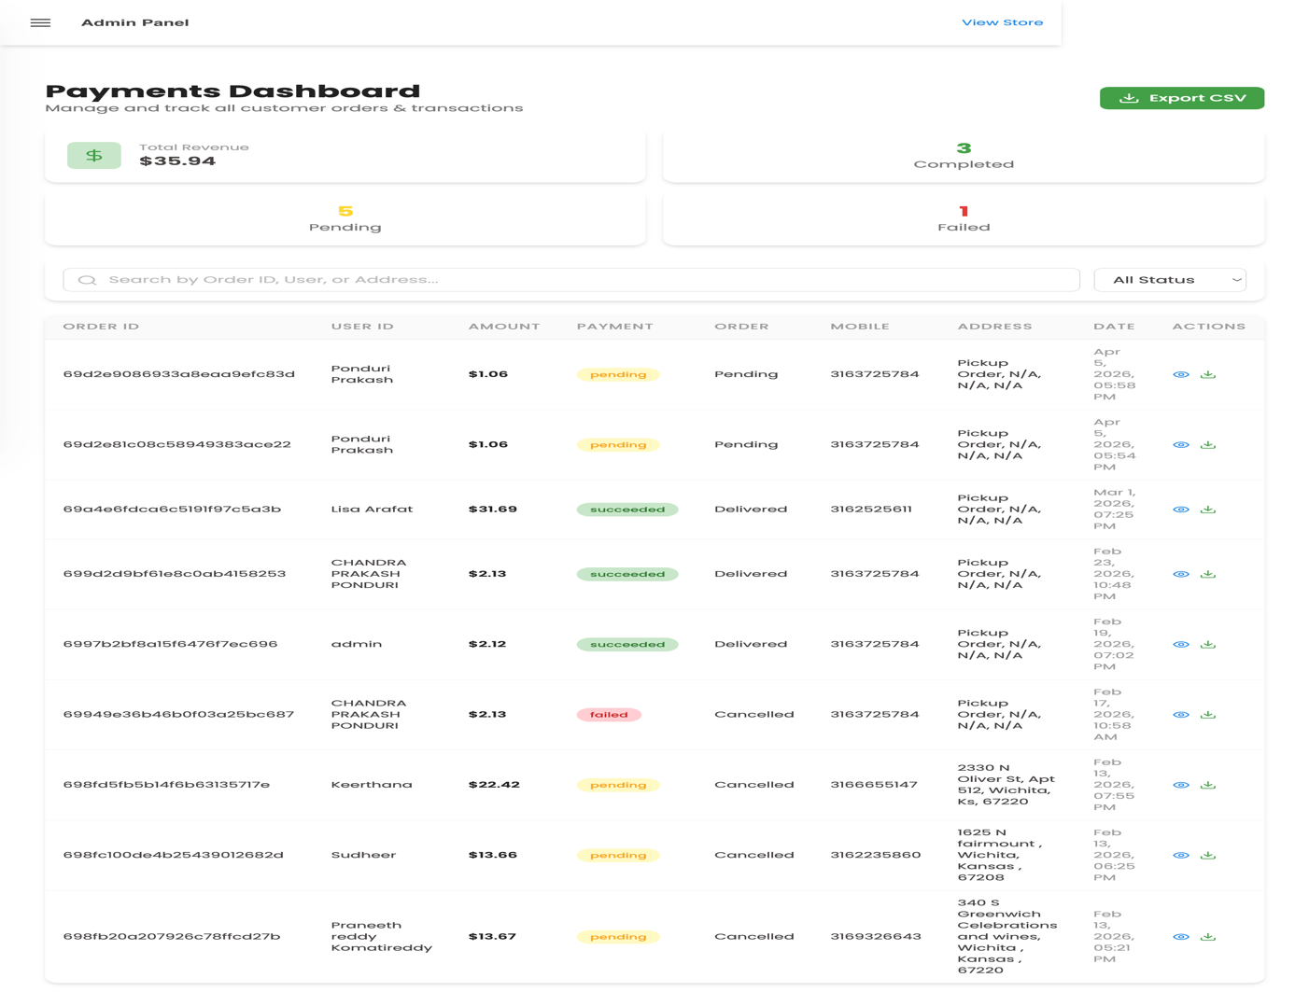

Media and Notifications
- Product image upload support for admin operations.
- Email notifications for password reset and order confirmation.
- Toast-based UI notifications for key actions and errors.

Core User Flows

Customer Shopping Flow
- User opens the home page.
- User chooses either Store or Cafe.
- User searches and filters products.
- User opens a product detail page.
- User adds items to cart.
- User reviews cart and updates quantities.
- User proceeds to checkout.
- User enters delivery/pickup details.
- User selects payment method (pickup/cash/card).
- User confirms order placement.
- User receives confirmation and can view the order in profile history.

Forgot Password / Reset Password Flow
- User opens the Forgot Password page.
- User enters registered email and submits request.
- Backend validates user and sends reset email with secure token link.
- User clicks reset link (/reset-password/:id/:token).
- User enters a new password.
- Backend verifies token and updates password.
- User logs in with the new password.

User Profile Update Flow
- User logs in and opens Profile page.
- User edits personal details (name, contact, address).
- User submits update.
- Backend updates user record.
- Updated profile is shown in UI and persisted for next sessions.

Admin Order Management Flow
- Admin logs in and opens /admin.
- Admin navigates to Orders section.
- Admin searches/filters orders by status/payment/user.
- Admin opens order details.
- Admin updates order status and/or payment status.
- Backend saves updates.
- Dashboard reflects updated order states.

Admin Product Management Flow
- Admin opens Products page.
- Admin adds a new product or edits an existing product.
- Admin updates fields (name, category, price, stock, discount, images).
- Admin saves changes.
- Product list/storefront reflects updated data.
- Admin can soft delete products when needed.

Payment Checkout Flow (Card)
- User reaches checkout and selects Card Payment.
- Frontend requests backend to create Stripe Payment Intent.
- Stripe PaymentElement is displayed to user.
- User enters card details and confirms payment.
- Payment is verified and order is finalized.
- Cart is cleared and order appears in user history.

Pages and Route Map:

Public Routes:
- / : Home page (entry point to Store and Cafe)
- /signup : New user registration
- /login : User login
- /passwordrequest : Forgot password request form
- /reset-password/:id/:token : Reset password page via secure token link
- /store : Grocery storefront
- /cafe : Cafe storefront
- /menu : Cafe menu section (visual/menu layout)
- /product/:productId : Product details page

Protected Customer Routes
- /mycart : Shopping cart page (requires login)
- /checkout : Checkout flow
- /profile : Profile management + order history (requires login)

Admin Routes (Protected, Admin Only)
- /admin : Admin dashboard overview
- /admin/products : Product management list
- /admin/addProduct : Add new product
- /admin/updateProduct/:productId : Update existing product
- /admin/users : User management
- /admin/orders : Order management
- /admin/payments : Payments dashboard
- /admin/reviews : Reviews dashboard (currently mock-data driven)

Route Protection Summary
- Customer protection: cart/profile routes require authenticated user.
- Admin protection: all /admin/* routes require authenticated admin role.
- Unauthorized users are redirected to login or blocked from admin pages.

Technology Stack

Frontend
- React (with Vite) for fast, component-based UI development
- Redux Toolkit for global state management
- React Router for client-side routing
- Tailwind CSS + Material Tailwind for styling and UI components
- Axios for API communication
- Stripe React SDK (PaymentElement) for card payments
- React Toastify for alerts and notifications
- Framer Motion / Swiper (where used) for interactive UI behavior

Backend
- Node.js + Express.js for REST API development
- JWT for authentication and authorization
- bcrypt/bcryptjs for password hashing
- Multer for handling file uploads
- Nodemailer for sending emails (password reset / order notifications)
- Stripe server SDK for payment intent creation

Database
- MongoDB Atlas as the cloud database
- Mongoose for schema modeling and database operations

Storage & Deployment
- AWS S3 for product image storage
- Vercel for frontend deployment
- Vercel for backend API deployment

Development Tools
- npm for dependency management
- Git/GitHub for version control and collaboration
- Postman (or similar API client) for endpoint testing

Conclusion
The Asia Bazaar Grocery and Cafe Ecommerce Application successfully transforms a traditional, manual ordering model into a modern digital experience. It brings customer shopping and business administration into one unified platform, making it easier for users to browse products, place orders, complete payments, and track order progress from anywhere.
From a customer perspective, the application improves convenience through clear product discovery, cart management, and a structured checkout flow that supports both pickup and delivery scenarios. Features like authentication, profile management, order history, and password recovery add reliability and usability for day-to-day use.
From an operational perspective, the admin module provides strong control over products, users, orders, and payments. This reduces manual overhead and helps staff manage daily processes with better visibility and faster updates. The full-stack architecture using React, Node.js, Express, and MongoDB also provides a scalable base for future enhancements such as advanced analytics, coupon systems, inventory forecasting, and richer reporting.
Overall, this project demonstrates a practical and production-ready ecommerce solution tailored to a real retail and cafe business workflow, with a strong foundation for long-term growth and feature expansion.

